How to Password Protect MS Word 2010
Article Source:
http://recoverlostpassword.com/article/password-protect-ms-word-2010.html

Microsoft Office 2010, the successor to Microsoft Office 2007, was released on April 15, 2010 and it has really simplified the process to password protect, lock and encrypt the documents. Now I’ll demonstrate how to password protect MS Word 2010, the newest version of Microsoft’s ubiquitous word processor for you.

Now follow this tutorial to password protect a Word 2010 document using built-in password encryption.

Step 1: Open the word document which you wish to password protected and encrypt

Step 2: Click the “File” tab, then Click on the “Info” option. On the right menu click on the “Protect Document” button under “Permissions”, and then select the “Encrypt with Password” option
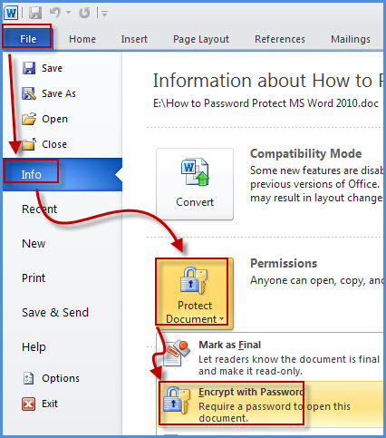
Step 3: When the “Encrypt Document” dialog appears, set a password for your word document and then click “OK” button.
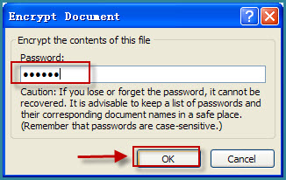
Then a “Confirm Password” dialog will appear, reenter your password and click “OK” button.
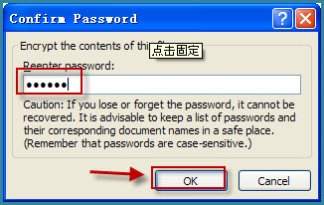
Step 4: After password protecting your word document, click “Save” or press Ctrl+S to save the document. Now your word document is password protected. You’ll see the following message “A password is required to open this document” under “Permissions”.
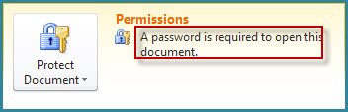
Note:
- It is exactly very important for you to password protect word document with a strong password. Using a simple password will be easy hacked or cracked by a password cracking application and get access to your word document with ease. Using a strong and long password will significantly increase the security of your document and decrease the likelihood of hacker will be able to break the encryption. See how to create strong passwords form Microsoft Online Safety.
- Word 2010 document has simplified the password protection feature. If you wish others to view your document but not change the content, you will have to use the old Password Protection dialog used with previous versions of Office. Only the word version before 2007 has the file sharing options. For the step-by-step on password protecting word document for sharing purposes, take a look at this article I wrote for password protecting MS word 2007 document.

